
Touchstones Project
Netcards

Interdependence Netcards with Text

Atmosphere HRJ
Banker HRJ
Bee HRJ
Borders HRJ

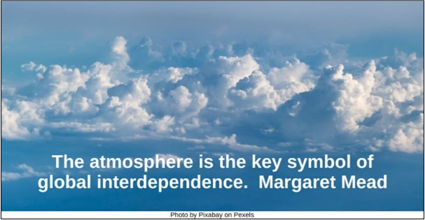



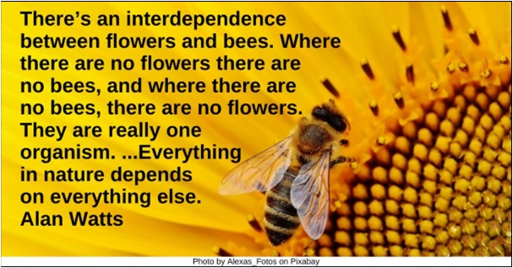

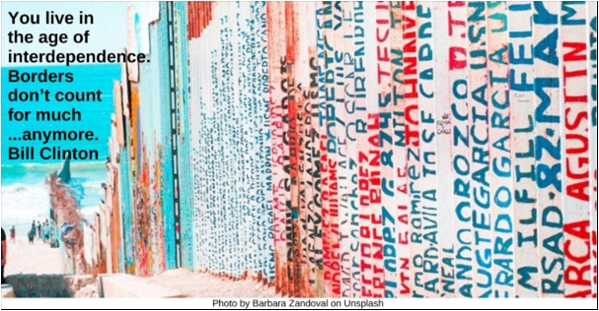

Buddha HRJ
Celtic HRJ
Child helping HRJ
Compassion HRJ

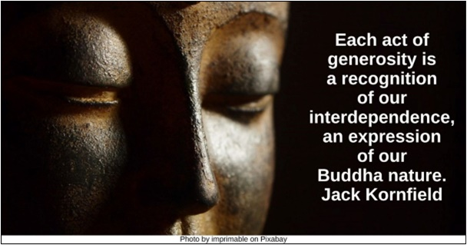

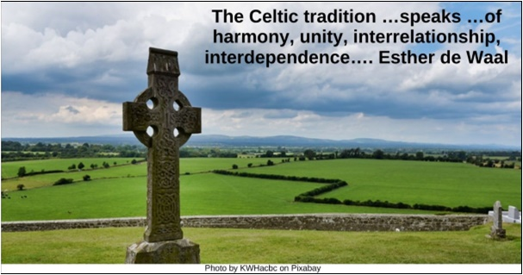

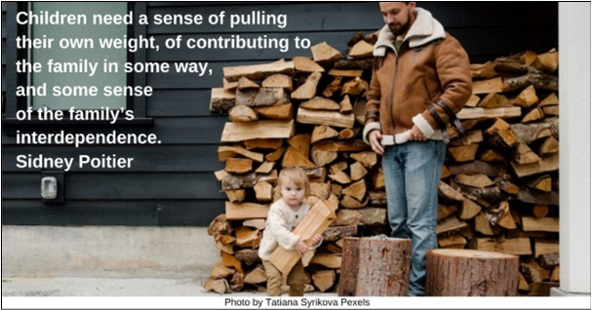

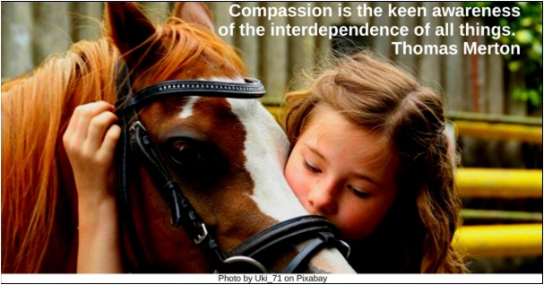

Connection HRJ
Cosmos HRJ
Couple HRJ
Creation HRJ

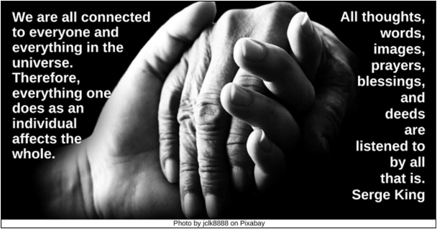

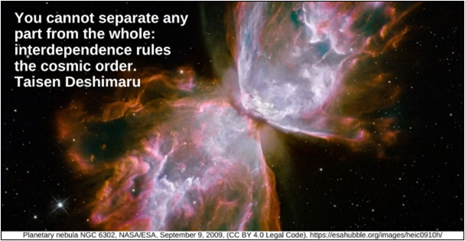

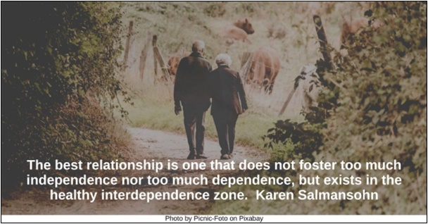

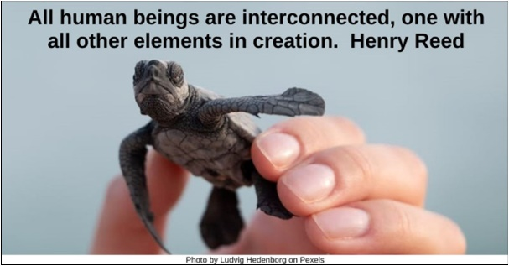

Earth HRJ
Fireflies HRJ
Flat Surface HRJ
Gratitude HRJ

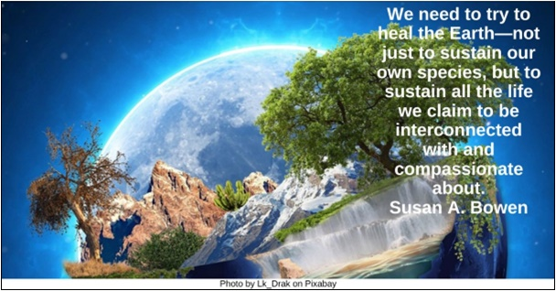

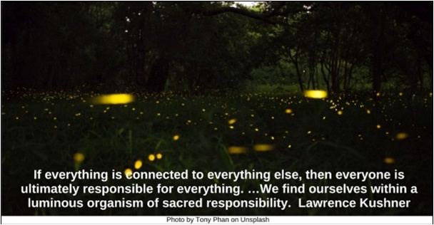

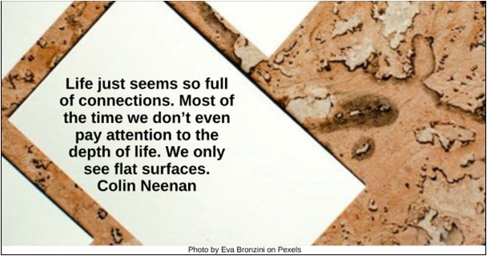

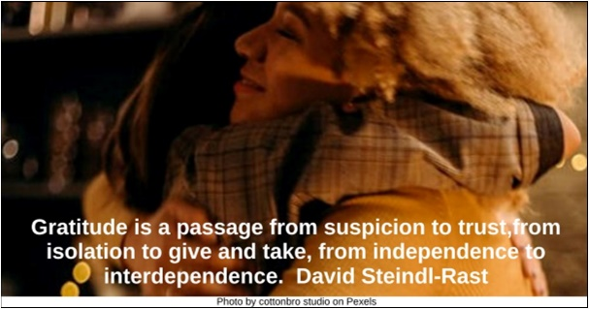

Holding Hands HRJ
Independence HRJ
Landscape HRJ
Liberty HRJ

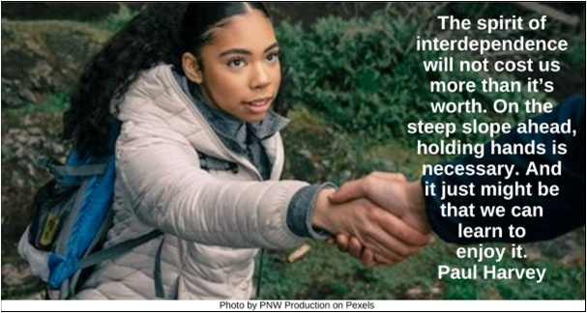

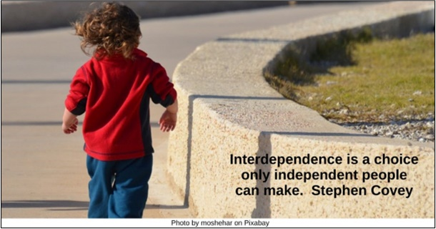

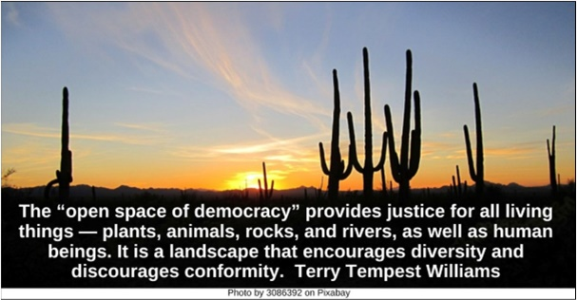

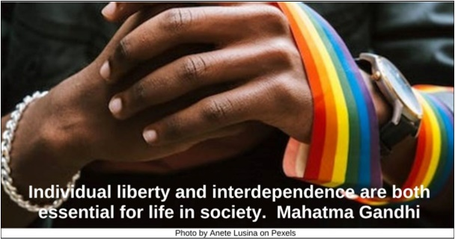

Mother and Child HRJ
Reading in Nature HRJ
Rippers HRJ
Scissors HRJ

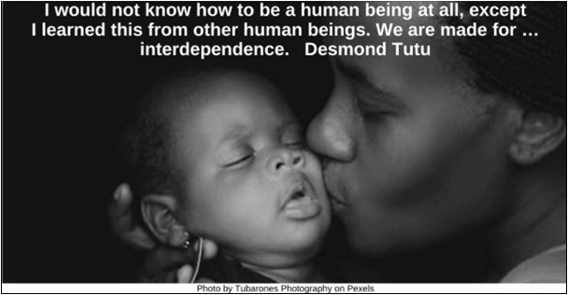

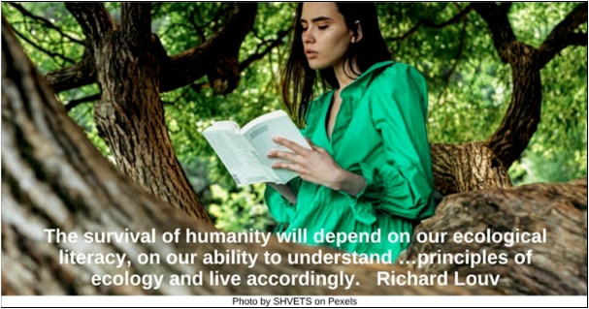

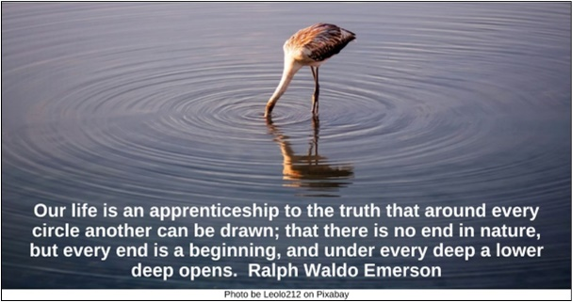

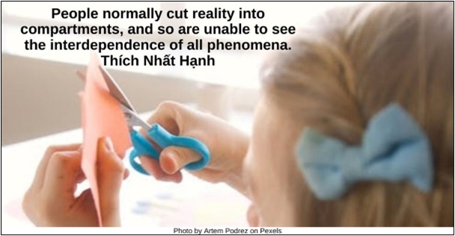

Stormy Sea HRJ
Team HRJ
Trees HRJ
Universe HRJ

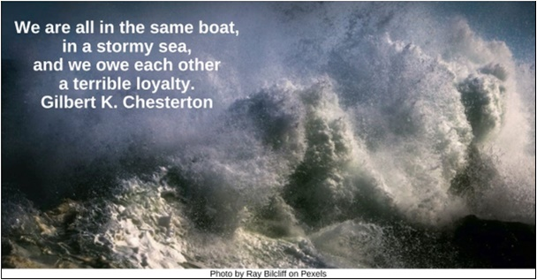

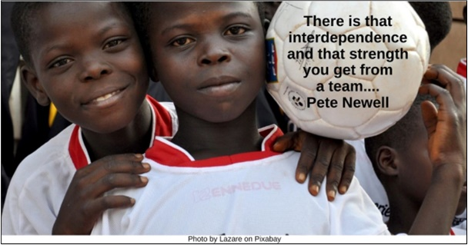

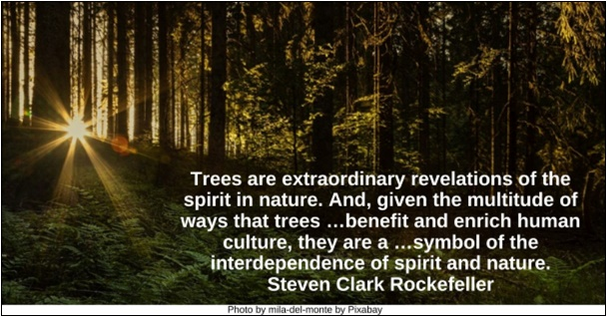

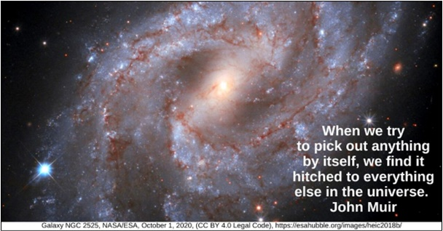

Wolf HRJ
World HR
Worth HRJ

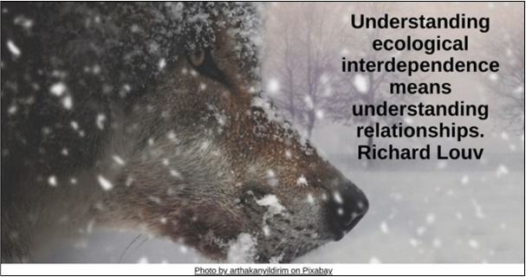

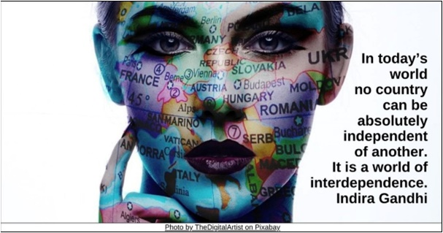

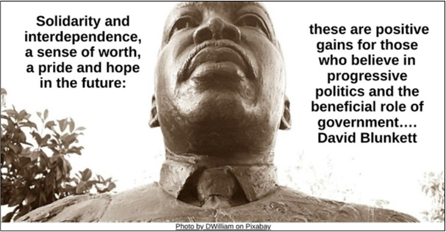

Text of Quotes
Atmosphere HRJ
The atmosphere is the key symbol of global interdependence. Margaret Mead

Banker HRJ
There is no such thing as a “self-made” man. We are made up of thousands of others. George Matthew Adams

Bee HRJ
There’s an interdependence between flowers and bees. Where there are no flowers there are no bees, and where there are no bees, there are no flowers. They are really one organism. …Everything in nature depends on everything else. Alan Watts

Borders HRJ
You live in the age of interdependence. Borders don’t count for much or stop much, good or bad, anymore. William J. Clinton

Buddha HRJ
Each act of generosity is a recognition of our interdependence, an expression of our Buddha nature. Jack Kornfield

Celtic HRJ
The Celtic tradition …speaks …of harmony, unity, interrelationship, interdependence…. Esther de Waal

Child helping HRJ
“Children need a sense of pulling their own weight, of contributing to the family in some way, and some sense of the family’s interdependence.” Sidney Poitier

Compassion HRJ
Compassion is the keen awareness of the interdependence of all things. Thomas Merton

Connection HRJ
We are all connected to everyone and everything in the universe. Therefore, everything one does as an individual affects the whole. All thoughts, words, images, prayers, blessings, and deeds are listened to by all that is. Serge King

Cosmos HRJ
You cannot separate any part from the whole: interdependence rules the cosmic order. Taisen Deshimaru

Couple HRJ
The best relationship is one that does not foster too much independence nor too much dependence, but exists in the healthy interdependence zone. Karen Salmansohn

Creation HRJ
All human beings are interconnected, one with all other elements in creation. Henry Reed

Earth HRJ
We need to try to heal the Earth—not just to sustain our own species, but to sustain all the life we claim to be interconnected with and compassionate about. Susan A. Bowen

Fireflies HRJ
If everything is connected to everything else, then everyone is ultimately responsible for everything. …We find ourselves within a luminous organism of sacred responsibility. Lawrence Kushner

Flat Surfaces HRJ
Life just seems so full of connections. Most of the time we don’t even pay attention to the depth of life. We only see flat surfaces. Colin Neenan

Gratitude HRJ
Gratitude is a passage from suspicion to trust, from isolation to give and take, from independence to interdependence. David Steindl-Rast

Holding Hands HRJ
The spirit of interdependence will not cost us more than it’s worth. On the steep slope ahead, holding hands is necessary. And it just might be that we can learn to enjoy it. Paul Harvey

Independence HRJ
Interdependence is a choice only independent people can make. Stephen Covey

Landscape HRJ
The “open space of democracy” provides justice for all living things — plants, animals, rocks, and rivers, as well as human beings. It is a landscape that encourages diversity and discourages conformity. Terry Tempest Williams

Liberty HRJ
Individual liberty and interdependence are both essential for life in society. Mahatma Gandhi

Mother & Child HRJ
I would not know how to be a human being at all, except I learned this from other human beings. We are made for …interdependence. Desmond Tutu

Reading in Nature HRJ
The survival of humanity will depend on our ecological literacy, on our ability to understand …principles of ecology and live accordingly. Richard Louv

Ripples HRJ
Our life is an apprenticeship to the truth that around every circle another can be drawn; that there is no end in nature, but every end is a beginning, and under every deep a lower deep opens. Ralph Waldo Emerson

Scissors HRJ
People normally cut reality into compartments, and so are unable to see the interdependence of all phenomena. Thích Nhất Hạnh

Stormy Sea HRJ
We are all in the same boat, in a stormy sea, and we owe each other a terrible loyalty. Gilbert K. Chesterton

Team HRJ
There is that interdependence and that strength you get from a team…. Pete Newell

Trees HRJ
Trees are extraordinary revelations of the spirit in nature. And, given the multitude of ways that trees …benefit and enrich human culture, they are a …symbol of the interdependence of spirit and nature. Steven Clark Rockefeller

Universe HRJ
When we try to pick out anything by itself, we find it hitched to everything else in the universe. John Muir

Wolf HRJ
Understanding ecological interdependence means understanding relationships. Richard Louv

World HRJ
In today’s world no country can be absolutely independent of another. It is a world of interdependence. Indira Gandhi

Worth HRJ
Solidarity and interdependence, a sense of worth, a pride and hope in the future: these are positive gains for those who believe in progressive politics and the beneficial role of government…. David Blunkett

